The GenAI Augmentation Paradox: Evaluating Synthetic Data in Low-Data Image Classification

Akul Ameya
Bachelor of Data Science
S P Jain School of Global Manegement
Sydney, Australia
akul.bs23dmu006@spjain.edu.au
Nhat Quang Bui
Bachelor of Data Science
S P Jain School of Global Manegement
Sydney, Australia
nhat.bs23dsy049@spjain.org
Aayush Aneja
Bachelor of Data Science
S P Jain School of Global Manegement
Sydney, Australia
aayush.bs23dmu002@spjain.org
Cahyani Karunia Putri
Bachelor of Data Science
S P Jain School of Global Management
Sydney, Australia
cahyani.bj24dsyu03@spjain.org

Abstract — We study image classification in a low-data regime on Tiny ImageNet. Our central question is whether synthetic images from pretrained diffusion models can recover performance lost when only 5% of training data is available, and whether any recovery reflects genuine representation improvement. We introduce three pipelines: Baseline (5% real), DiffusionBoost (5% real + synthetic), and Ceiling (100% real). Stage 1 establishes a robust data pipeline, trains a ResNet-18 baseline, and produces accuracy, calibration, robustness, and representation diagnostics. The model achieves 37.15% Top-1 accuracy with ECE 0.0398. In Stage 2, we will extend to diffusion augmentation and investigate whether synthetic utility varies across classes.
Keywords— Low-data classification, synthetic data augmentation, diffusion models, Tiny ImageNet, calibration (ECE), representation geometry, ResNet-18.

Problem Definition
We study image classification in a low-data regime on Tiny ImageNet (200 classes, 64×64 images). Our central question is whether synthetic images generated by large pretrained diffusion models can recover performance lost when only 5% of the real training data is available, and whether any apparent recovery reflects genuine representation improvement rather than trivial data smoothing.
Formally, the input is an image $x∈R^{3×64×64}$ and the output is a class label $y∈\left\{1,…,200\right\}$. The low-data setting (5% of Tiny ImageNet, i.e., 25 images per class) makes the problem challenging due to overfitting, miscalibration, and brittleness to small corruptions. We introduce three pipelines: (1) a Baseline trained on 5% real images with classical augmentations, (2) a DiffusionBoost model that mixes real images with class-conditional synthetic samples from Stable Diffusion, and (3) a Ceiling model trained on the full Tiny ImageNet training set.
Stage 1 focuses on building a robust data pipeline, training a pretrained ResNet-18 backbone, and producing initial accuracy, calibration, robustness, and feature-geometry diagnostics. In Stage 2, we will extend this pipeline with diffusion-generated synthetic data and investigate whether the benefit of augmentation is uniform across classes — with implications for how synthetic data should be generated and allocated.

Mini Literature Survey
Modern computer vision systems often rely on large annotated datasets, yet many practical applications operate in data-scarce environments. When training data is limited, deep neural networks frequently suffer from overfitting and unstable generalization. Large pretrained models partially alleviate this issue by transferring knowledge learned from large-scale datasets. [1] show that models such as CLIP maintain strong robustness when used in a zero-shot setting, but conventional fine-tuning can degrade robustness under distribution shift. They propose WiSE-FT, a method that interpolates between the weights of zero-shot and fine-tuned models to retain robustness while improving target-task accuracy. Their results highlight the importance of carefully adapting pretrained models when only limited labelled data is available.
Generative models have recently emerged as a promising approach for addressing data scarcity. Diffusion models, first formalized by [2], generate images by iteratively denoising samples drawn from a Gaussian distribution. Later work demonstrated that large-scale text-to-image diffusion models can produce high-quality images across diverse domains. [3] introduced latent diffusion models, which enable efficient high-resolution image generation by performing diffusion in a compressed latent space. These advances have made diffusion models practical tools for generating synthetic training data for downstream tasks.
Recent studies have investigated whether diffusion-generated images can improve discriminative model performance. [4] demonstrate that large text-to-image diffusion models can be fine-tuned to produce class-conditional synthetic images for ImageNet classification. Their experiments show that augmenting real training data with generated images improves classification accuracy across multiple architectures, including ResNet and Vision Transformer models. These findings suggest that diffusion models can provide meaningful supervision signals when combined with real training data.
Several works have explored how synthetic data can improve learning under challenging dataset conditions. [5] propose a diffusion-based augmentation framework for long-tailed food classification datasets. Their method generates synthetic images using both positive and negative prompts to increase intra-class diversity while improving inter-class separability. Experiments on Food101-LT and VFN-LT show improved classification accuracy compared with existing long-tailed learning approaches. Similarly, [6] introduce DA-Fusion, a diffusion-based augmentation method that generates semantically modified variations of real images. Their approach produces richer augmentations than traditional geometric transformations and improves few-shot classification accuracy across multiple domains.
Another line of work studies how synthetic and real data should be combined during training. [7] propose MixDiff, a framework that integrates diffusion-generated images into self-supervised learning pipelines. Their results show that models trained using both real and synthetic images achieve improved robustness and transfer performance compared with models trained solely on real data, suggesting that synthetic data can enrich representation learning when used appropriately.
Beyond accuracy improvements, augmentation strategies have also been studied for their impact on robustness. [8] show that data augmentation methods such as CutMix and MixUp can significantly improve adversarial robustness when combined with model weight averaging. These findings demonstrate that carefully designed augmentation strategies can improve both generalization and robustness of deep learning models.
Finally, recent work has examined how training modifications influence the internal representations learned by neural networks. [9] analyze representation similarity using metrics such as Centered Kernel Alignment (CKA), showing that representation similarity measures can reveal functional relationships between neural networks trained under different conditions. Such representation analysis techniques provide a useful framework for understanding how synthetic augmentation affects the structure of learned feature spaces.
Building on these studies, the present work investigates diffusion-based synthetic augmentation in a controlled low-data classification setting using Tiny ImageNet [10]. Unlike prior work that focuses primarily on accuracy improvements, our study evaluates synthetic augmentation across multiple axes including accuracy recovery, calibration [11], robustness, and representation geometry using a pretrained ResNet architecture [12]. Expected Calibration Error (ECE), introduced by [11], measures the discrepancy between predicted confidence and empirical accuracy using confidence binning.

Exploratory Data Analysis
We use Tiny ImageNet as a controlled yet realistic benchmark. The full dataset contains 200 classes with 500 training images and 50 validation images per class. To simulate a low-data regime, we construct a deterministic 5% stratified subset of the training split: for each class, we randomly sample 25 images (seeded), yielding exactly 5,000 training samples.
Our EDA confirms that the resulting subset is perfectly balanced by design (25 images per class), eliminating class imbalance as a confound. Figure 1 shows a grid of sample images spanning multiple classes to qualitatively inspect diversity and label quality.
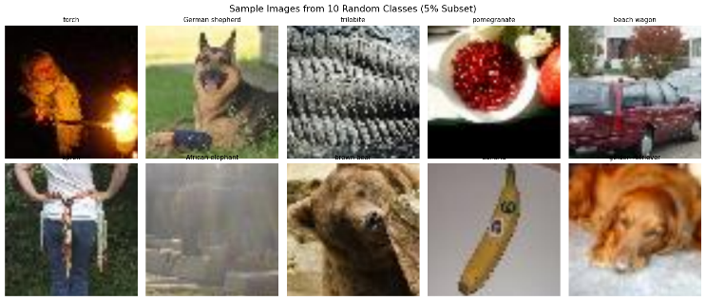
- Sample images from the 5% Tiny ImageNet subset across multiple classes
All images are originally 64×64 pixels; a simple size histogram verifies the uniform resolution. We compute channel-wise statistics on a sample of the 5% subset: mean = [0.480, 0.448, 0.398], std = [0.277, 0.269, 0.282] (RGB), broadly consistent with ImageNet and justifying the use of ImageNet normalisation. We resize inputs from 64×64 to 224×224 because ResNet-18 pretrained weights expect ImageNet-scale spatial features; upscaling preserves compatibility with the pretrained convolutional filters. We apply standard augmentations (random crops, horizontal flips).

Baseline and Proof of Concept
Our baseline model is a ResNet-18 pretrained on ImageNet. We replace the final fully connected layer with a 200-way classifier to match Tiny ImageNet classes and fine-tune the model on the 5% subset using cross-entropy loss and AdamW (learning rate 3×10⁻⁴, batch size 64) for 5 epochs. All experiments use mixed-precision training on a single RTX 4060 GPU.
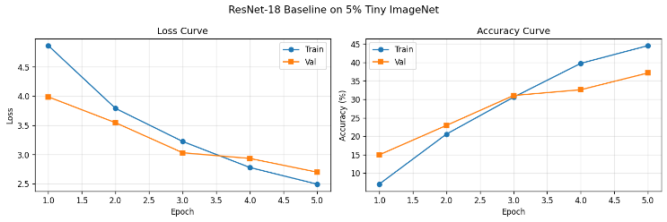
- Training Loss and validation accuracy over 5 epochs for the ResNet-18 baseline
The model achieves 37.15% Top-1 accuracy on the Tiny ImageNet validation set after 5 epochs, which satisfies the Stage 1 requirement of obtaining a non-trivial baseline. Sample predictions on held-out images confirm the pipeline runs end-to-end.
Beyond accuracy, we compute Expected Calibration Error (ECE) on the validation set and obtain ECE = 0.0398. ECE measures the calibration gap between predicted confidence and empirical accuracy. Figure 3 shows the reliability diagram, indicating the model is mildly over-confident in this low-data setting.
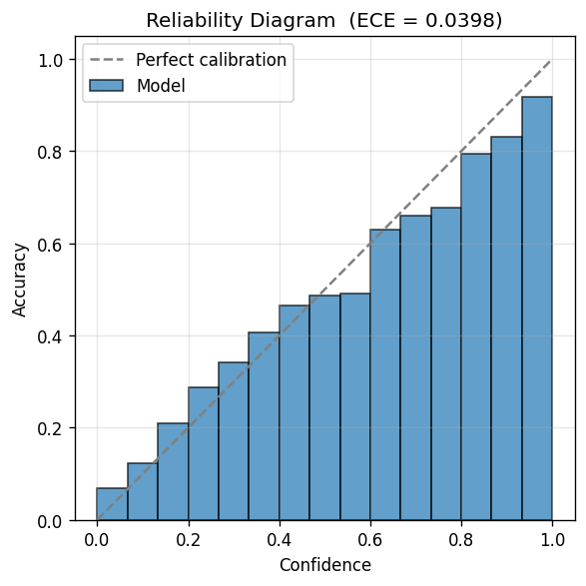
- Reliability diagram (ECE = 0.0398) on the full validation set
We also perform a corruption benchmark with specified intensities: Gaussian noise (σ = 0.1), Gaussian blur (kernel size 5), and brightness shift (+0.2). Accuracy drops from 37.15% on clean data to 10.17%, 36.72%, and 31.15% under these perturbations, quantifying robustness. Per-class validation accuracy varies substantially across the 200 classes (Figure 4); this distribution provides the baseline for Stage 2 analysis of which classes benefit from synthetic augmentation.
Finally, we extract penultimate-layer features, compute the covariance eigenvalue spectrum, and train a linear probe, obtaining 42.00% accuracy — providing an initial snapshot of representation geometry for later comparison against diffusion-augmented models.
In Stage 2, we will introduce class-conditional synthetic images from Stable Diffusion and evaluate the augmented pipeline across calibration, robustness, and representation geometry using CKA similarity and feature covariance spectra. We will examine whether synthetic utility varies across semantic categories, and whether class-level properties from this baseline can predict which classes benefit. Experiments will be replicated on a second lightweight architecture to test generalisability.

References
- M. Wortsman, et al., “Robust fine-tuning of zero-shot models,” in IEEE/CVF Conference on Computer Vision and Pattern Recognition (CVPR), 2022.
- J. Ho, A. N. Jain, and P. Abbeel, “Denoising diffusion probabilistic models,” in NeurIPS, 2020.
- R. Rombach, et al., “High-resolution image synthesis with latent diffusion models,” in IEEE/CVF Conference on Computer Vision and Pattern Recognition (CVPR), 2022.
- S. Azizi, et al., “Synthetic data from diffusion models improves imagenet classification,” in Transactions on Machine Learning Research, 2023.
- G. Koh, et al., “Synthetic data augmentation using pre-trained diffusion models for long-tailed food image classification,” in IEEE/CVF Conference on Computer Vision and Pattern Recognition Workshops (CVPRW), 2025.
- B. Trabucco, et al., “Effective data augmentation with diffusion models,” unpublished, arXiv, 2023.
- R. A. Bafghi, et al., “Mixdiff: mixing natural and synthetic images for robust self-supervised representations,” in IEEE Workshop/Winter Conference on Applications of Computer Vision (WACV), 2024.
- S-A Rebuffi, et al., “Data augmentation can improve robustness,” in NeurIPS, 2021.
- T. Cui, et al., “Deconfounded representation similarity for comparison of neural networks,” in NeurIPS, 2022.
- J. Deng, et al., “Imagenet: a large-scale hierarchical image database,” in IEEE/CVF Conference on Computer Vision and Pattern Recognition (CVPR), 2009.
- C. Guo, et al., “On calibration of modern neural networks,” in International Conference of Machine Learning, 2017.
- K. He, et al., “Deep residual learning for image recognition,” in IEEE/CVF Conference on Computer Vision and Pattern Recognition (CVPR), 2016.

